Buying Iona
In April 2021 we sold Cornish Lady, a Sadler 29 that we had jointly owned with Alison and Chris for several years. Alison and Chris have decided to spend their lives sailing the dream and have bought a boat which is presently based in Greece. We were therefore boatless, a state that I find completely unbearable!
We talked for some time about the Bavaria 30 as a possible purchase particularly as they appeared to be a lot of boat for the money. In the Spring of 2021 boat prices were still fairly reasonable but boats were going quickly so whenever we saw a possible boat we rushed off to have a look at it. Many of you know I was suffering from particularly bad sciatica which in the end wiped out the whole of our summer culminating in a back operation in November and as a result viewing boats became extremely difficult and we had to be fairly sure it was worth the journey before arranging a viewing. The summer dragged on and every time we found a possible boat it was sold before we even left Weymouth.
In September we spotted a Beneteau 311 Oceanis Clipper for sale in Plymouth and at a reasonable price and we quickly made an appointment to view it and as soon as we saw the her we knew this was the boat for us. We had not even contemplated a Beneteau but she was in good condition and had obviously been well looked after by the owner who was reluctantly selling her due to his wife’s ill health. By the time we left the Marina we had decided to make an offer without bothering with a survey. We felt that a hugely expensive surveyor would probably only tell us things we already knew and it was worth the risk of not taking her out of the water. Two weeks later we were the proud owners of Iona.
Having bought the boat we needed to get her back to Weymouth – I was unable to sail or do anything useful on a boat so David asked Michael Gill and Nigel Page to help him sail it back. Diana kindly drove them down to Plymouth and after stowing their gear and checking over the boat they left in absolutely no wind for Weymouth. They had a very pleasant but windless trip back with an overnight stop in Dartmouth and with my friend Ellie I was able to get out to Portland Bill to welcome them home waving fairly large flags.
Since Iona’s arrival in Weymouth we have taken her out into the Bay a couple of times but only in light winds due to my back still healing but we had an enjoyable pre Christmas drinks party on board when we were joined by other Club members and David seems to have spent many happy hours “fiddling”. We joined in the day cruise out to East Shambles buoy at the beginning of April in fairly windy weather which was our first proper sail in the boat.
Our aim is to join in the Club cruise to Yarmouth at the end of April and maybe go west in July plus Club day cruises throughout the summer. All provided the X ray at the beginning of May shows my spine has fused properly and the consultant gives me the all clear.
As an appendix to this David has written a short piece on the “fiddling”, sorry work, he has done on the boat over the winter

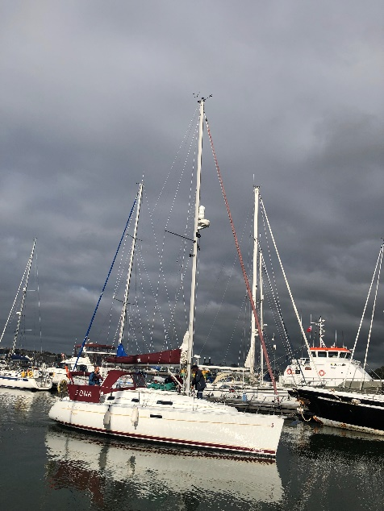 Leaving Plymouth
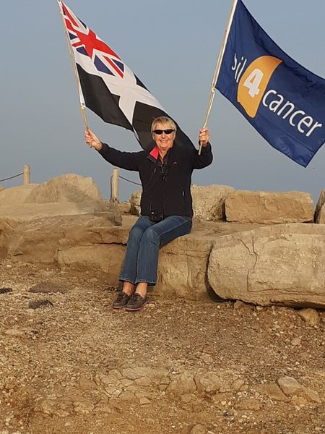 Welcome Home
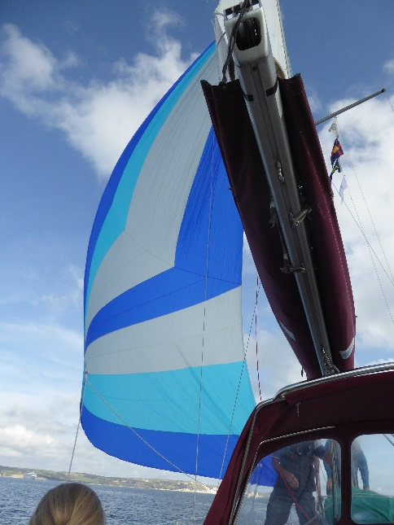 Spinnaker flying in Weymouth Bay

