So, we had found our boat which ticked all the right boxes. Sit back and enjoy? Of course not, now to get it organised to our liking!
I rerouted all the running rigging back to the cockpit. (All the fittings were there, but not well organised) Then after a very gentle trial sail, we discovered that we needed turning blocks for the cruising shoot sheets, and that we needed a divertor to prevent halyard wrap on the forestay. The first was easy, the second required two strong helpers to hoist me up the mast.
Then I replaced all the interior lights with LED bulbs, a cheap job’ but it increased the lighting levels at less amps.
We decided that we should move with the times, and fit an “em-trak” AIS transceiver from JG Tech (Weymouth). Diving into the wiring of a boat is always an adventure, with lots of spare wire all over the place. Fortunately there was a redundant wire from the chart table to the binnacle, so with some “field installable” Micro C connectors, also from JG, I was able to interface to the Raymarine Chartplotter, and also the VHF and the Navtex.
Next up was the battery set up. The original arrangement had two switches, allowing one or both batteries to supply all services. With this set up, it is possible to drag down the voltage when starting the engine, and tripping the instruments. I like to keep Engine and House batteries separate, so I fitted a Bluesea Add a Battery Kit. which includes an Automatic Charging Relay. Now one switch turns on both batteries, but keeping the supplies separate. A further quarter turn of the switch combines the batteries if needed.
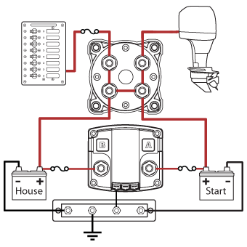
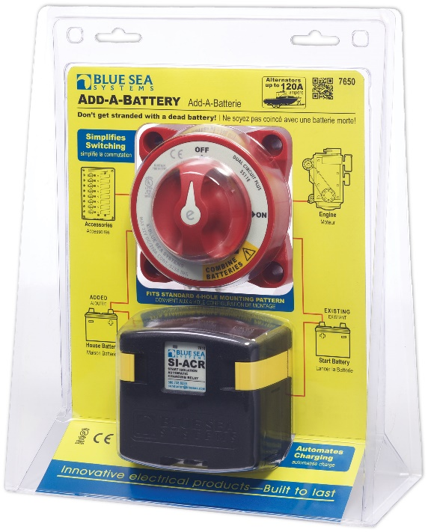
Now we’re into the little jobs: sorting out the stowages; making an anchor snubber; changing from Camping gas to Calor; and so on.
Next major task will be to change the VHF radio. We were going to live with the rather strange Swedish radio, but this week we noticed that the handset cable was falling apart. So I will be collecting a new radio when we get back from Yarmouth.

